Parking Management System

COMP 246 (SEC.006)

Instructor: Mohammad Anwar Hossain

**Students:**

* Aesha Bhatt 301034022
* Minh Chau Hoang 300946197
* Xiaohui Hao 300878632
* Gaofeng Pan 300973143
* Carlos Zabaleta 301002235

**TABLE OF CONTENTS:**

1) Problem Statement-----------------------------------------------------------------3

2) Workflows by Subsystem:--------------------------------------------------------4

Activity UML Diagrams

a)Use Cases & Actors By Subsystem

b) Use Case Diagram

c) Users Stories for each goal listed by subsystem

3) Domain Class Diagram-----------------------------------------------------------12

4) ER Diagram-------------------------------------------------------------------------13

5) List Technology & Tools for Project Development-------------------------14

6) Project Plan-------------------------------------------------------------------------15

**Vision Statement**:

College Parking Application is a mobile app which gives the facility to the students and employees to have all the information related to the College Parking as payments, real-time parking slot availability and the car’s pick up location.

**Problem Description**:

During weekdays it is more difficult to find a parking slot available in different colleges. It is a waste of time driving around to get an available slot, besides it may be difficult to remember your parking spot location, in case you were in a hurry or you forgot where you parked your car.

Hence we believe the best solution is to develop a mobile application to make different payments, it provides the current location of your car and it also provides the parking slot availability in the college.

**System Capabilities:**

* It provides students or employees the accurate maps of the college’s parking.
* It displays the current location of your vehicle.
* It displays the best route to the nearest parking slot available.
* It reminds you where you parked your car.
* It provides a method of payment for the students and the employees.
* It displays the fastest route from your location to the parking slot where your car is located.
* The system doesn’t provide the same quality of service as the students or faculty members.

**Business Benefits:**

* Makes it easier for the customers to find a parking slot available, therefore the customer would save time finding a parking slot available and getting to the parking slot where the car is located.
* Reduce the cost of managing the system.

**Workflows by Subsystem:**

**Activity Diagram**:

The activity diagram stimulates the workflow of how our application will work. The diagram starts from the time user drive the car near the parking lot to notify how many parking slots left and to the end when the user leaves the car

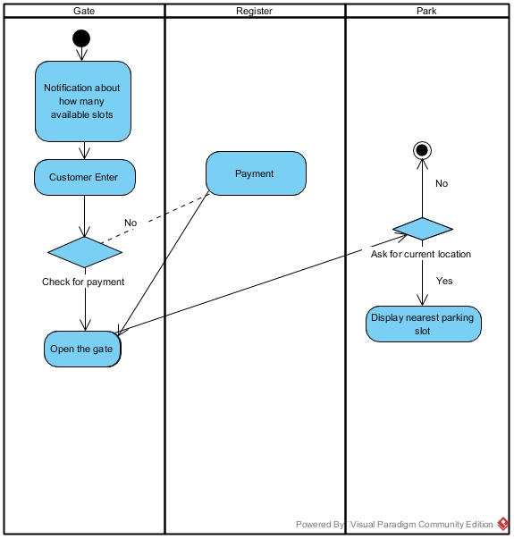

Fig 2.1- Activity Diagram for Parking Management System

**Use Cases and Actors by Subsystem:**

In this part, the use cases are represented as a subsystem. There are 3 subsystems:

1. Student Subsystem
2. Mobile Application Subsystem
3. Visitor Subsystem

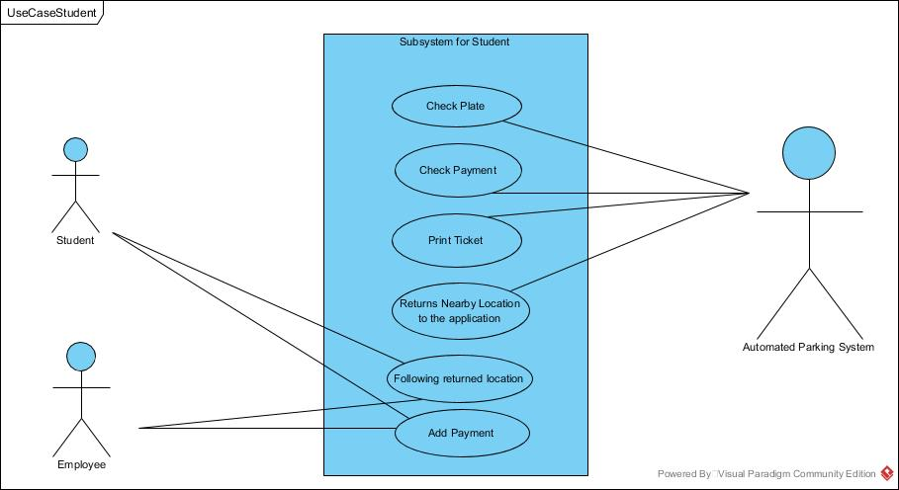

Fig 2.2- Use Case for Student Subsystem

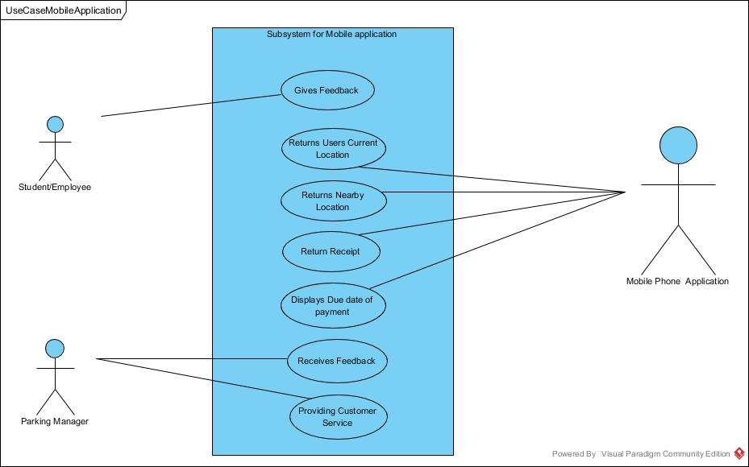

Fig 2.3 -Use Case for Parking Manager, student and Mobile Phone Application Subsystem

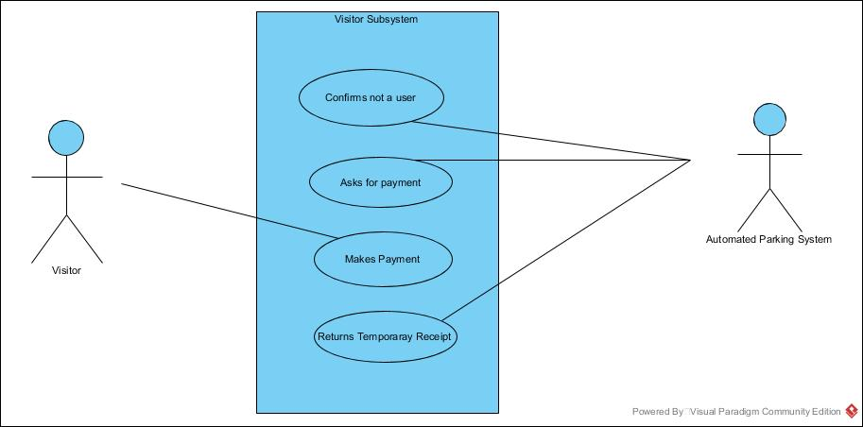

Fig 2.4- Use Case for Visitor Subsystem

**Use Case Diagram of the System:**

The Use Case Diagram familiarises with the actors and their functionality.

The actors are User (who uses the system), Mobile Phone Application,Automated Parking System and the Parking Manager.

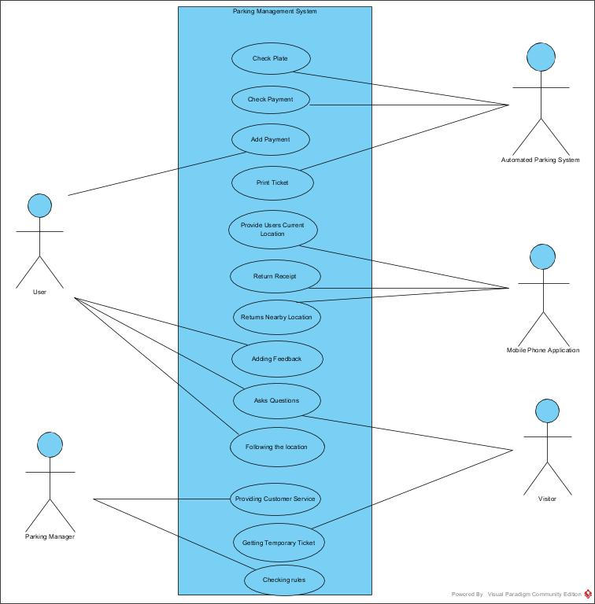

Fig 2.5- Use Case Diagram

**Users Stories:**

|  |  |  |
| --- | --- | --- |
| Use Case | User Story | Acceptance Criteria |
| Follow  Returned  Location | As a student/employee, I want to follow the navigation to an empty slot on my phone screen | 1. The APP should be installed, required rights should be given.  2. 4G Internet is required.  3. GPS chips in the phone are needed.  4. Maps of the parking lot are highly accurate.  5. Customer account information and car plate should be stored on the database.  6. Two states of slot “occupied” “empty” should be dynamic real-time updated on the database. |
| Add Payment | As a student/employee, I want to add payment automatically. | 1. Customer account information and car plate should be stored on the database.  2. Gate camera should scan plate and identify the customer.  3. Check time and cut money from prepayment account automatically. |
| Add Feedback | As a student/employee, I want to add feedback or make an emergency call. | 1. Words or pieces of voice can be recorded in APP for feedback.  2. The emergency call can be made by mobile or through phones which are installed at every gate of the parking lot. |
| Receive Feedback | As a parking manager, I want to receive feedback in APP | 1. Feedback can be a list in the database server. |
| Provide  Customer  Service | As a parking manager, I want to answer a customer’s emergency call and provide customer service. | 1. Customer’s current location should be displayed to the manager as soon as the emergency call is connected. |
| Make Payment | As a visitor, I want to make payment in payment machine. | 1. The visitor has own parking area.  2. The state of the slot in the visitor area is not controlled by the database system.  3. Visitor parking area provides payment machine and accessing card.  4. Figure out parking time by inserted accessing card picked up when entering. |

**Background:**

Wayne is one of the students in Centennial College. Recently he is very happy because he made a lot of money by himself. His car dream comes true finally.

He bought a TOYOTA Corolla and applied a plate for it. Then he went to the college website, opened a parking account, linked his license plate to his account and charged 200 dollars in it.

Finally, he downloaded our application and gave it required rights in his newest iPhone.

**Processes:**

Monday morning, Wayne drove his new car to school in a happy mood. When closed to the school parking lot, he started the APP by “HI SIRI”.

Until now the APP got the right to read current car location through GPS chips in mobile and communicate with our servers by the Internet. The current car location was sent to servers and empty parking slot was sent back.

The nearest parking slot was displayed on the iPhone screen immediately and the automatic navigation between the current location and the slot was shown after 3 seconds. Also, User can select different empty slots and decide where to park.

Wayne drove into school. When he stayed in front of the parking gate for a second, the automated parking system scanned plate of the car, checking numbers with plate database in servers, identified customer information. The parking time started now.

The state of parking account was transmitted between servers and mobile APP continuously. It includes the time, parking place and cost.

Wayne followed navigation, drove to the nearest parking slot. To make it easier, the slot’s ID number was displayed on the mobile screen and it is also marked on the slot ground. Signboards of slot number also are placed at different Connor around the whole parking lot.

After stopping, Wayne touched “DONE” button on the mobile screen. The location was recorded and would not be changed with people’s movement. And this parking slot was marked as “occupied” in our automated parking system.

Afternoon, Wayne finished his last class, went back to his car and left. He can choose any gate to leave. When stayed in front of the gate, camera scanned his plate again, matched his account, stopped parking time, figure out cost and cut money from the account. The system also set his previous slot state into “empty” for next parking car.

When leaving, there is no need to start the APP. Nevertheless, the customer is able to start the APP at any time to see the state of car parking (in case forget parking slot, the customer can see which place his/her car is parking at), get a receipt, charge money and check the balance.

The APP also provides feedback function. If customers meet any problem or have any suggestions, they can write it done in APP or upload pieces of voice record. The emergency customer servers’ phone number is also in the APP.

There are two ways of an emergency call. One is by mobile, the location of the customer is sent to parking managers immediately and if they must come, they will go straight to your car. Two is through interphones which are installed at every gate of the parking lot. Once connected, you can talk to it. If managers have to come, they will come to the place of talking interphone.

**Domain Class Diagram:**

The multiplicities of the Domain Class Parking Management System can be explained as follows:

The user has only one Parking Account but the Parking account may have zero or more Payment details. Parking Manager holds zero or more parking information, also it checks through zero or more parking availability. It can interact with zero or more users but the user can interact with only one Parking Manager. Users specialize to Students, Employees, and visitors and hence acts as a Super Class.

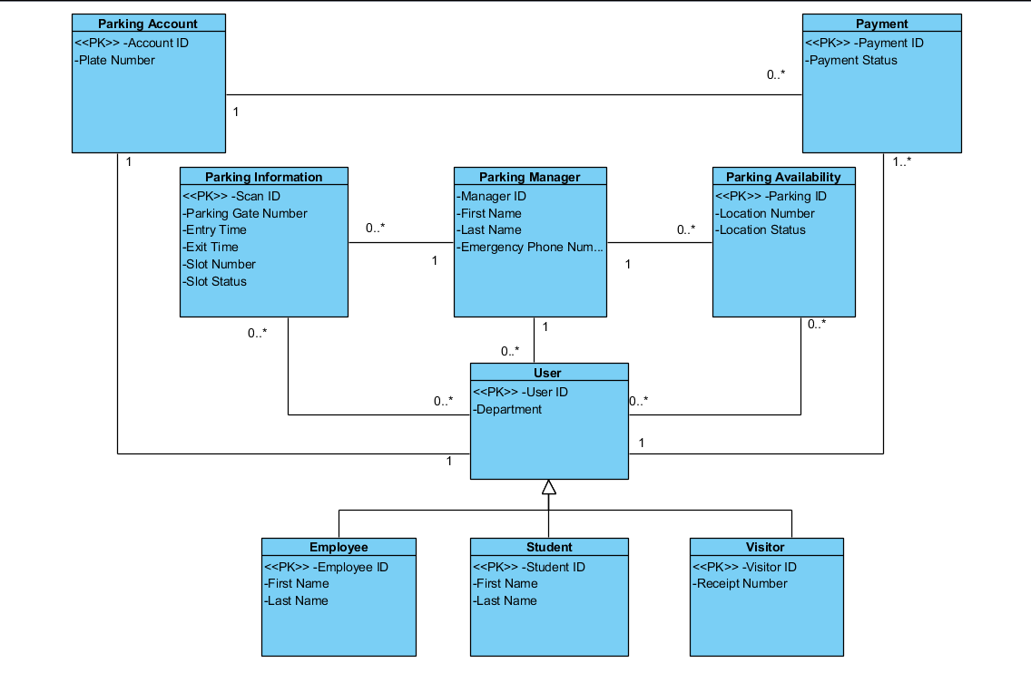

Fig 3.1- Domain Class Diagram

**Entity-Relationship Diagram:**

The Entity Relationship Diagram consists of four classes - User, Phone Information, Parking Data and Parking Manager with their relevant attributes.

The cardinalities for the ER Diagram can be represented as:

Student, Employee, Visitor generalizes to User who has one-one cardinality with his Phone(A user can get information through one Phone only). The parking information returns data for zero or user to zero or more devices. The Parking Manager follows only one Parking data provided but can interact with zero or more users.

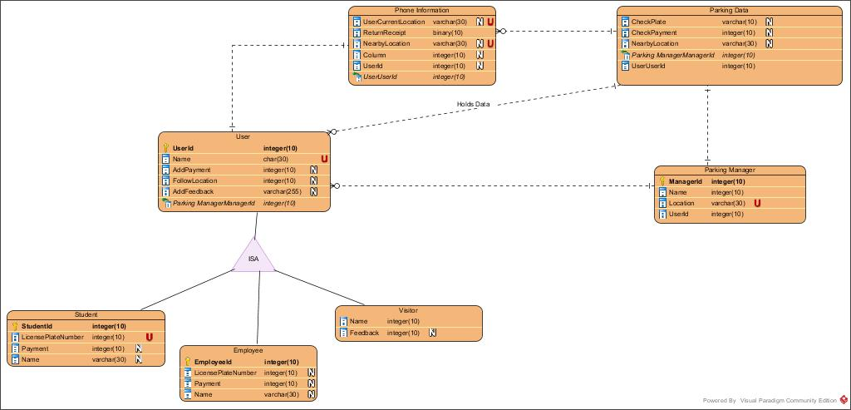

Fig 4.1- Entity Relationship Diagram

**Lists Technology tools for Project Development to date:**

Technologies used to develop this system are:

Software

* Visual Paradigm
* Microsoft Project
* LibreProject
* Office 2016

**Project Plan:**

In the following project plan, we show the different activities and times required to accomplish the main objective which is to provide the facility to the students and employees to have all the information related to the College Parking.

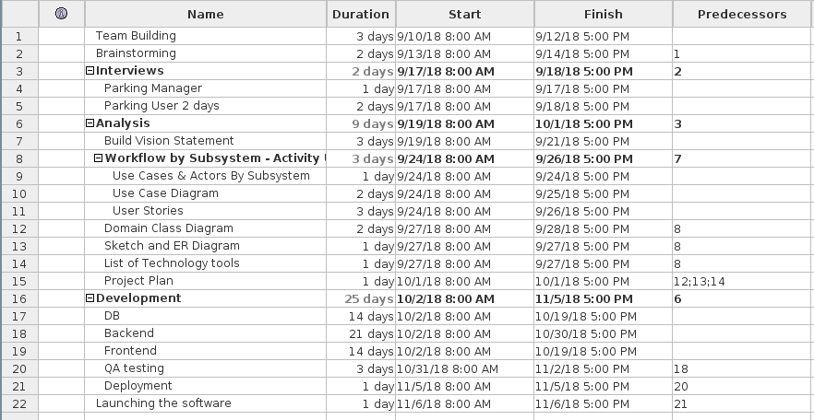

Fig 6.1- Gantt chart - activities, duration, start and finish date

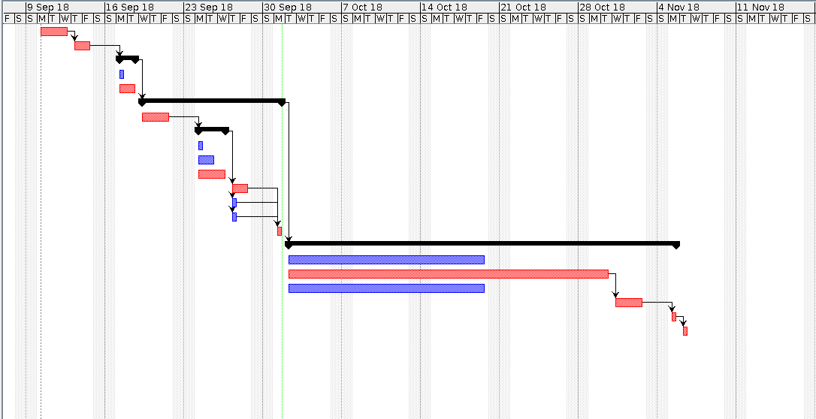

Fig 6.2-Gantt chart - duration of activities